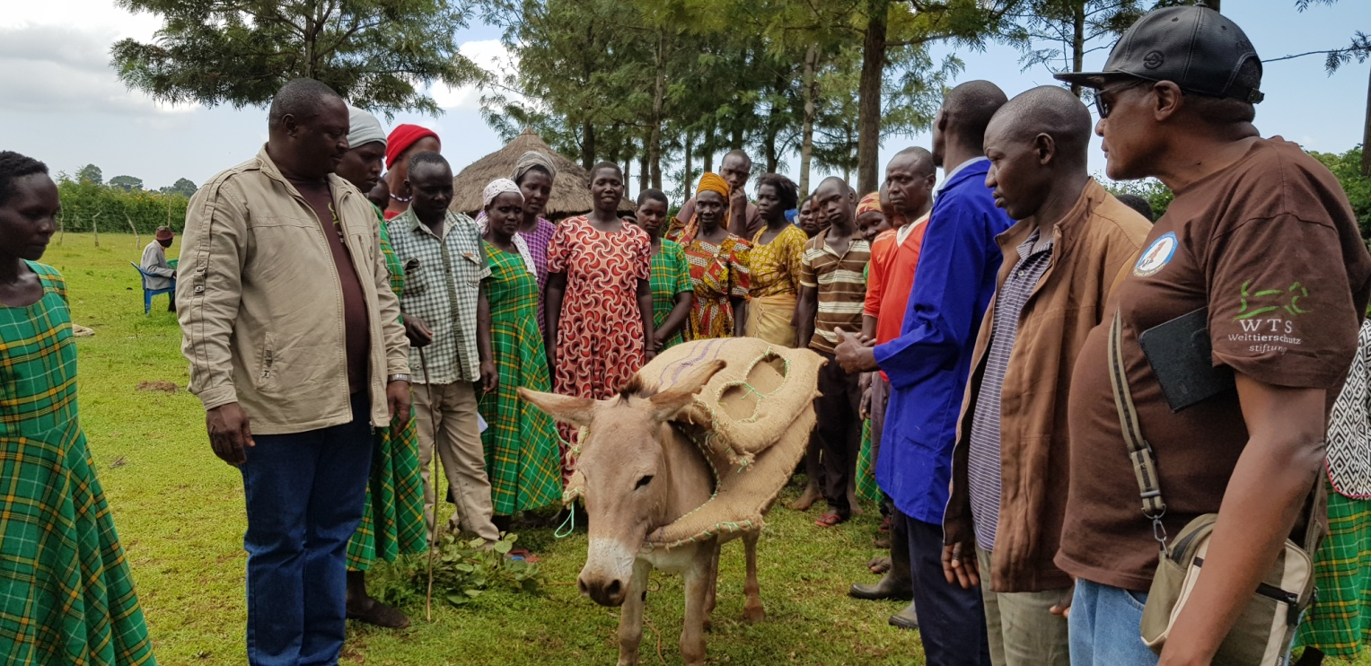
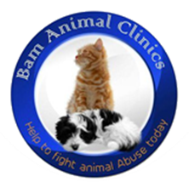
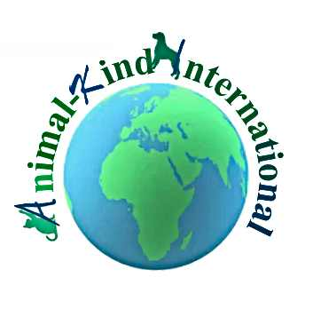
AKI ANIMAL WELFARE TRAINING REPORT

- Name of the organization
BAM ANIMAL CLINICS, Nakavule village , Iganga
ADDRESS: P. O BOX 55 IGANGA UGANDA
TELEPHONE +256 772487712
Email : balondemu_dav@bamanimalclinics.net
Website: https://bamanimalclinics.net

- Project title:
A PROJECT TO TRAIN DONKEY OWNERS TO MAKE SISAL SACKS SADDLES FOR DONKEYS TO PROTECT THEM FROM INJURIES AND WOUNDS DUE TO POOR HARNESSING HANNESES IN KWEEN DISTRICT BINYINY SUBCOUNTY KONO PARISH.
3 16th Sep to 16TH Oct 2019
4. Objective and Background of the training.
To train donkey owners on how to make sisal sack saddles for donkeys to protect them from ill health due to wounds caused by poor/no harnessing in the Eastern region of Uganda with primary emphasis to Kween District.
Donkeys are a major form of transportation of food, fire wood, water in Kween district especially considering that it is a hilly area with a very poor road network. Quite often, women are the major users of these donkeys to transport food and firewood to markets and other urban areas. Veterinary services are available mainly in the larger centers and the rural areas are less well serviced, with very limited or even no mobile clinics, veterinary services are considered too expensive to use.
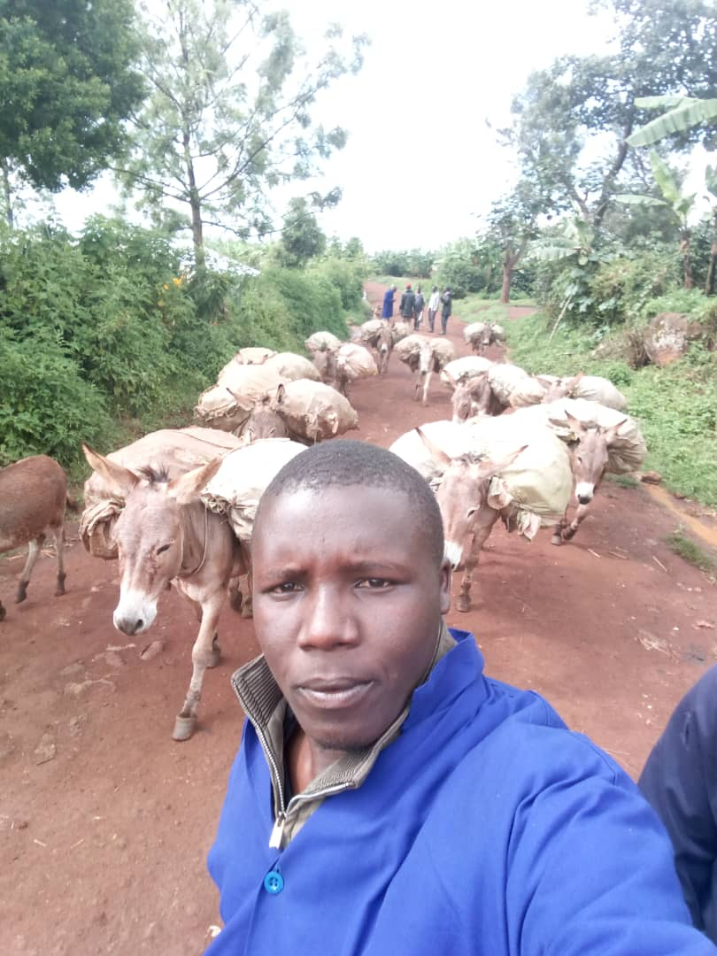
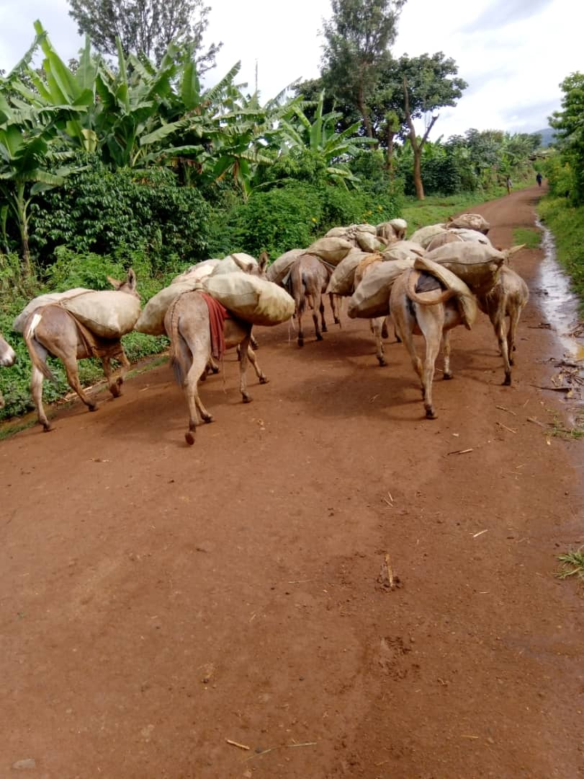

Government policy is to post a vet surgeon per sub-county assisted by at least 2 to 3 paravets. We have1403 sub-counties in Uganda and most are rural. That would need 1403 vets and double the number of paravets yet there are only about 1014 vets and 1502 paravets. The irony is that most vets posted in these rural areas come back to partly or wholly work in towns or peri-urban for better pay and residency / personal accommodation thus leaving most rural areas in dire need of expert vet services, quite often the paravets take-up the big role as they mostly stay in the rural. Most animals are in the rural areas which thus receive inadequate veterinary care and thus exposed to unnecessary pain and suffering (low donkey welfare).
We found out that Health challenges exist arising from inadequate housing and feeding, worm infestation, and poor harnessing causing skin lesions. Donkeys are tethered outside their owners’ homes to restrain their movement until they are needed again.
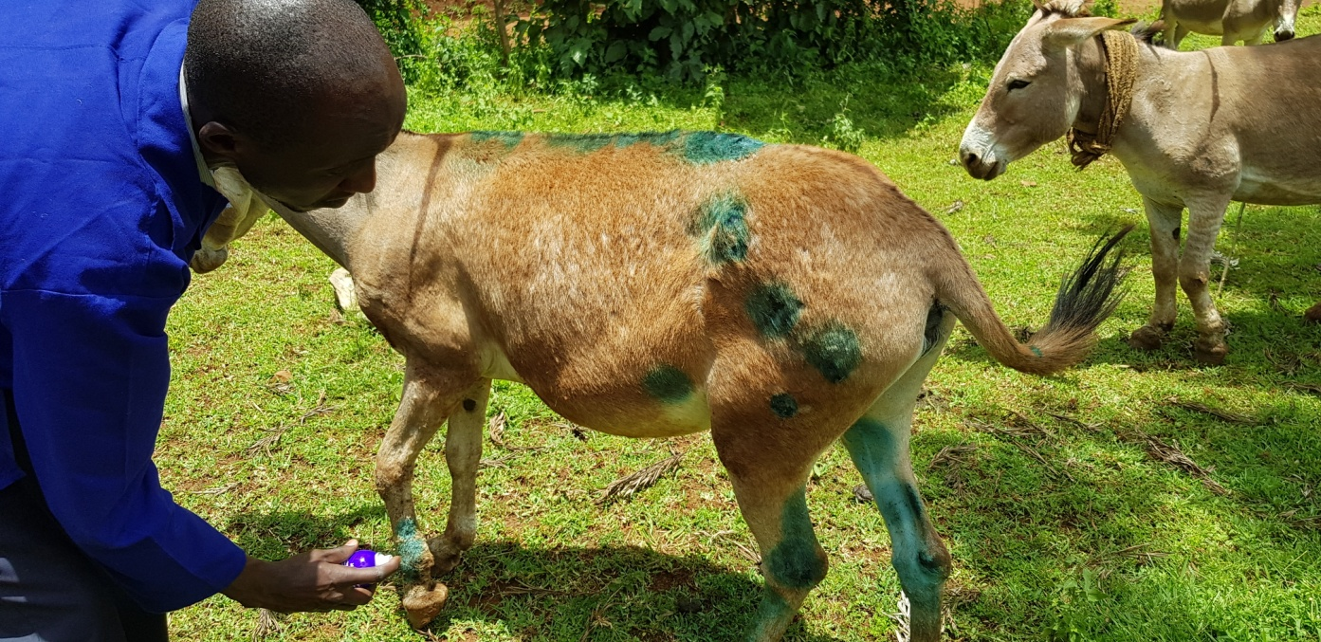

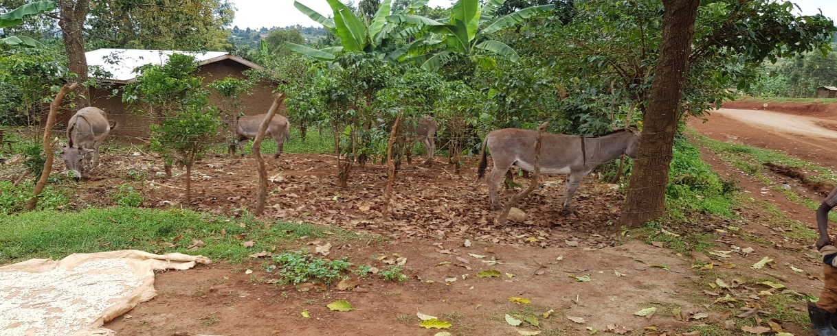
Donkey owners have no shelters and often donkeys are left in the rain and sun day in, day out. In the rainy seasons donkeys are confined to prevent them grazing in crops. It is often the responsibility of children to tether donkeys at safer sites and this calls for a humane education program in schools. Donkeys are slaughtered once they appear ill, or sold to butchers to meet financial obligations.

Course organization:
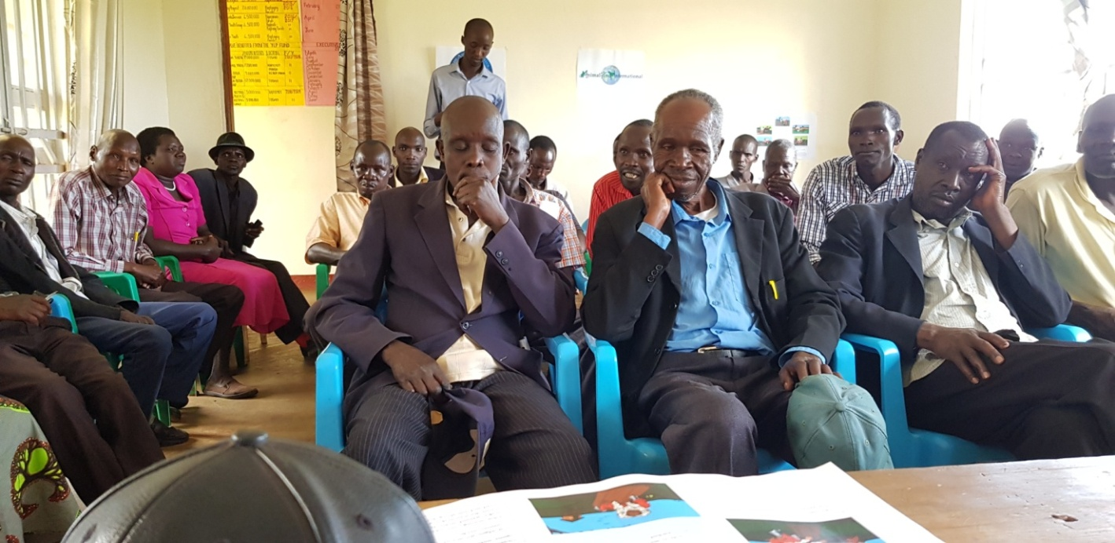
Firstly we were to train20 donkey owners on how to make sisal sack saddles for donkeys to protect them from ill health due to wounds caused by poor/no harnessing in Kono parish, Binyiny subcounty, Kween district, Eastern Uganda. Donkeys are a major form of transportation of food, fire wood, water in Kween district especially considering that it is a hilly area with a very poor road network

Since the harnessing is so poor and sometimes there is no harnessing, the donkeys are exposed to injuries and wounds that make them ill, unproductive and hence have a poor quality of life.

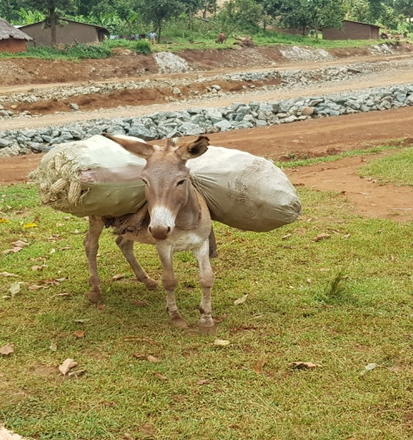
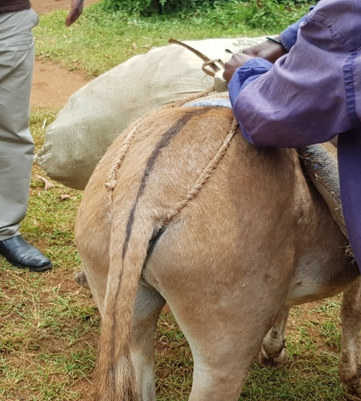
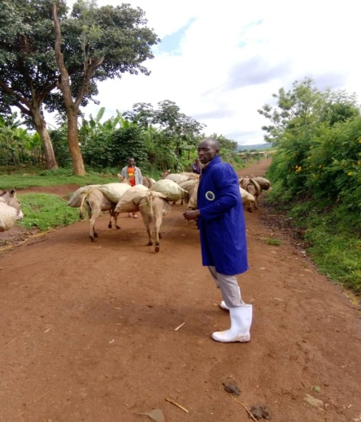

The easy to make and durable sisal sack saddle is very effective at cushioning the back of the donkey as well as the base of the tail from abrasion or cut wounds when donkeys are used to carry luggage.
The trained 20 donkey owners would then act as future trainers in their communities on how to make sisal sack saddles for donkeys to protect them from injuries and wounds due to poor harnessing.
Over 100 saddles were to be made to benefit over100 donkeys in the community
Activities :-
On the 16th of September 2019 , the Bam team comprising of Dr Balondemu David, Dr Kagoda Samuel and Dr Muhamudu Kalange set off for Kween District for a Five day training program. Had a stopover in Mbale town to make final purchases for the project.
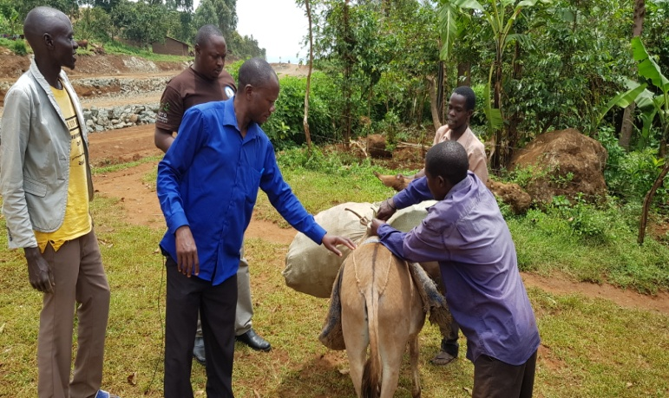
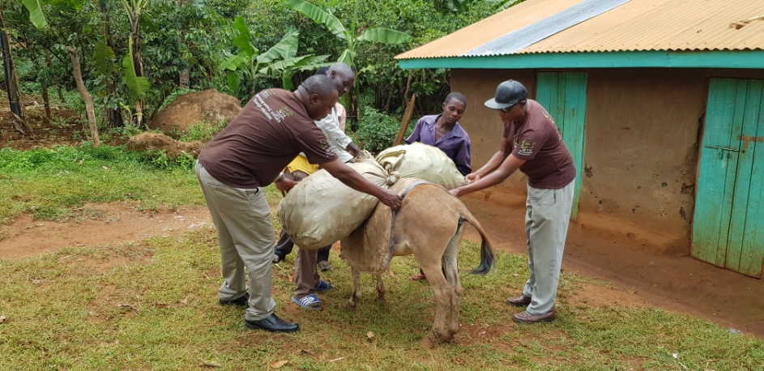

Our team on the ground in Kween comprising of Mr Kwemoi Collins and Cheroto Jonah were organizing our participants to train. It was a very long journey and just after Kapchorwa , we stopped to observe a poorly made saddle placed on a donkey to curry a very heavy load . We advised the donkey owner on how there was hope to make his donkey curry the load with less pain and help him even more than with the type of harness used at the time .
We arrived at Binyiny Sub county Kween District where our contacts had organized the meet and found everyone was awaiting our arrival.
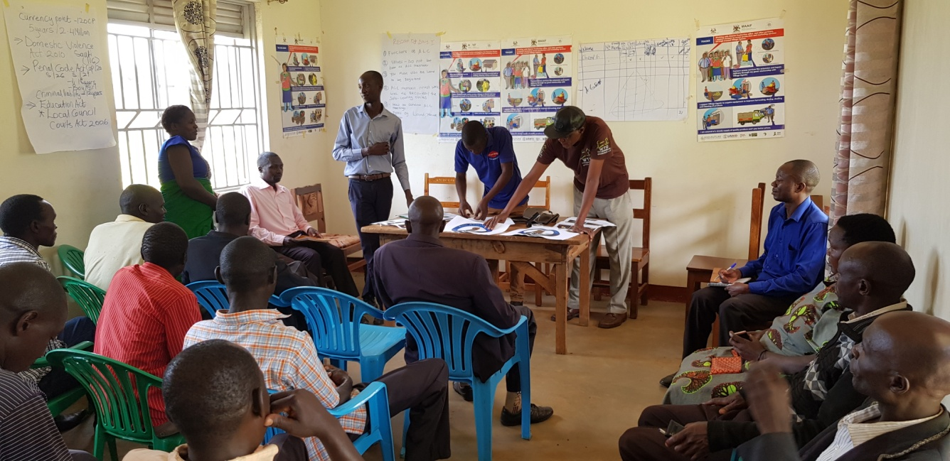
The first day :- We moved right to the radio station where we shared a lot about the donkey welfare On arrival at the subcounty, the team immediately started on the work , we were introduced to the sub county chief who was a very happy man to see our team , we briefed him about our program but the advance team had already made a pronouncement for the training to the office. We were then led to the boardroom where participants had gathered. Everyone introduced him/herself including the village he came from and the number of Donkeys he/ she had. We took the details in records .We did our introduction and also unveiled our project to them; the aim and objectives and the roadmap for the project.

Day two:- Day 2 involved a presentation of AKI programs worldwide based on their website , Presented by the Director Balondemu David. He also presented Bam programs in Uganda including animal welfare state in the country.
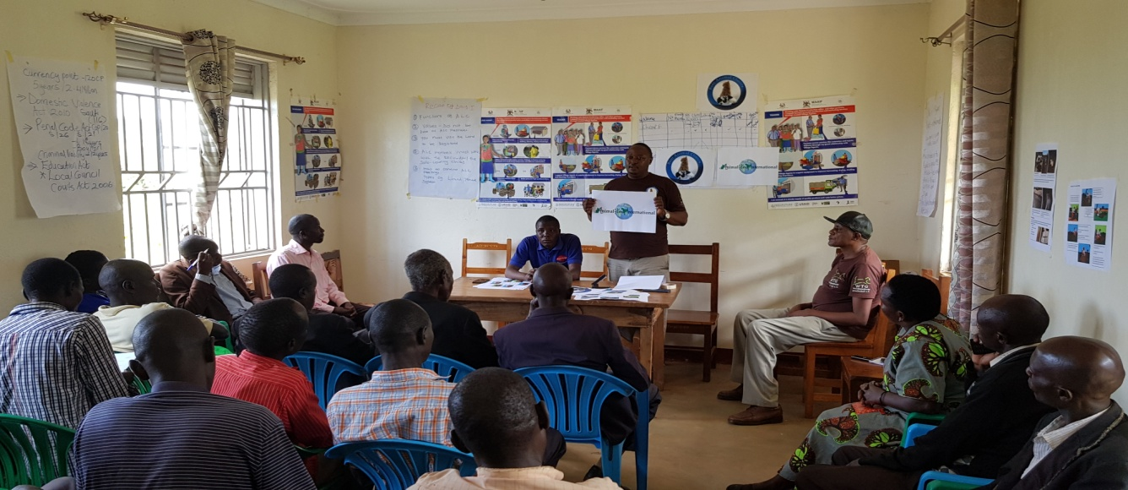
The Sisal Saddle initiative was launched and participants were led through photographic illustrations of how the new saddles are made. They were also made to discuss the advantages and disadvantages of using the sisal saddles as opposed to the traditional saddles. The sisal saddles were seen to be leading the traditional type. The entire class of 23 participants went through general demonstration by the Bam team, we made about five samples and by end of the day almost everyone had learnt how to make the saddles. We then formed five groups amongst the participants and the groups would the following morning convene at KONO parish center where we had organized field training outreach for practical hands on the animals. Each participant in the group was given a pairs of sacks and all the requirements for making a pair of saddles.

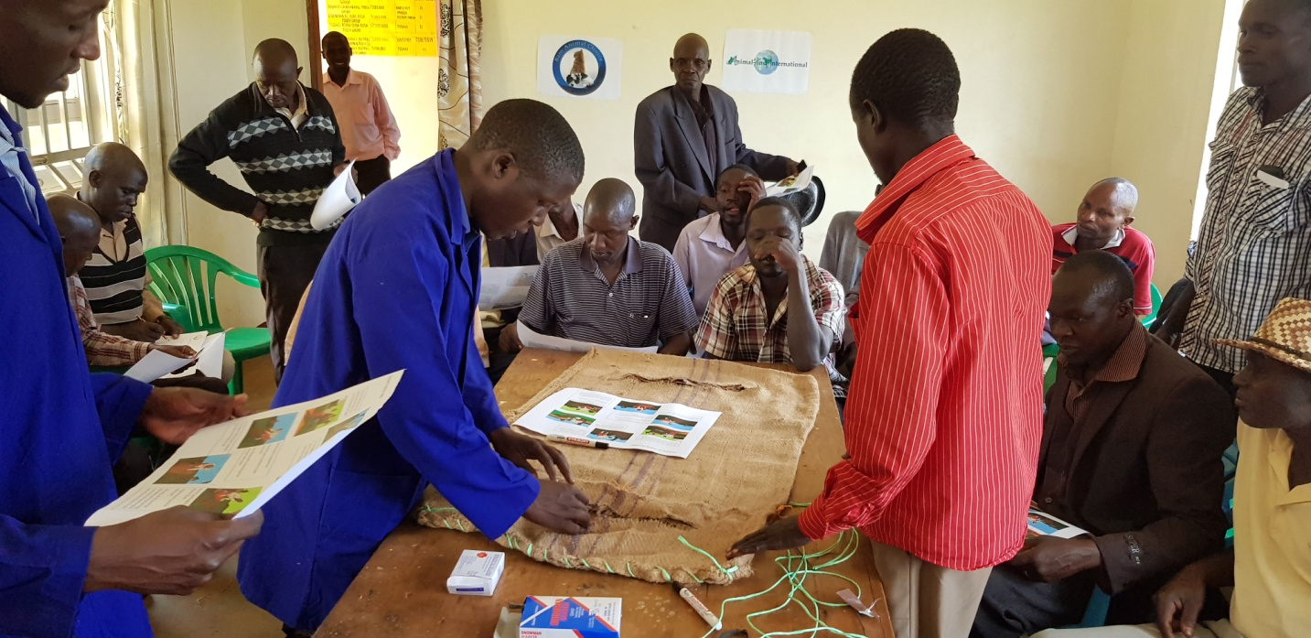
At end of the second day, 80% of the participants presented perfect results in making sisal sack saddles.

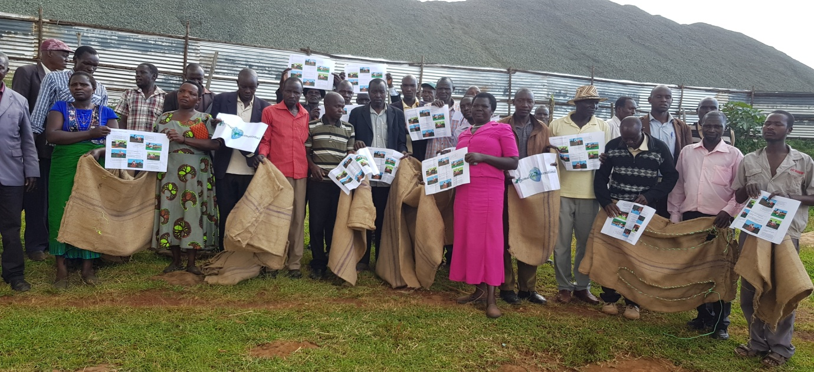
The third day we repeated the exercise to have the entire team master the process of making sisal sacks saddles. Each group members were still served with materials enough to make the saddle. Our observation indicated all members by close of the day were able to make perfect samples of saddles.

The Fourth day at Kono parish headquarter, locals were mobilized to bring donkeys on site and were invited to learn how Sisal saddles were made by their own trained representatives. There was a lot of excitement and everyone was seen yearning to learn the new method of making saddles.
However, there were so many challenges as many donkeys had different types of health conditions and some others requiring simple surgeries. There was a donkey seen walking with a lot of difficulties (Limping) and on observation had a lacerated hoof with stones stuck in. We preferred debridement and the damage was severe. We managed the wound very well and had to make a follow up the following day. To my chagrin, this donkey could not be spared to continue carrying loads despite the state of her limb! We however advised the owner to keep her for quite a while before considered for any work lest she would lose the animal.
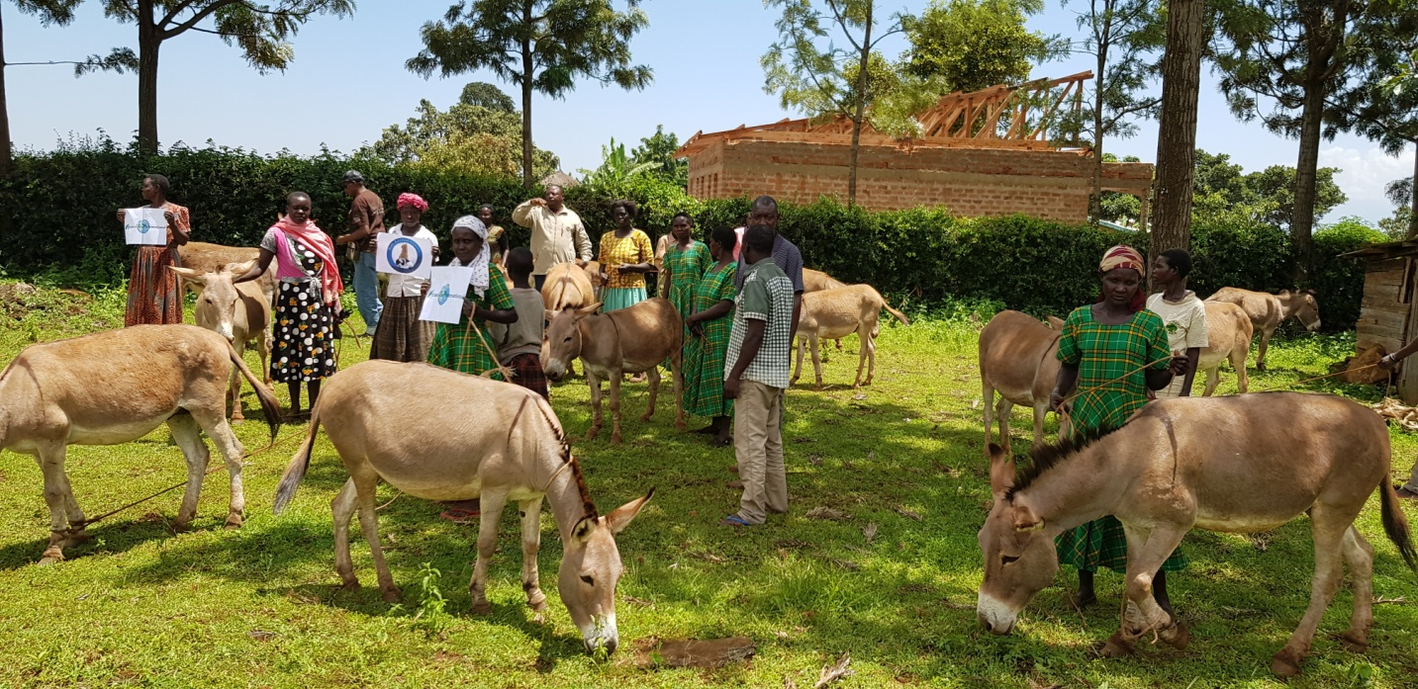

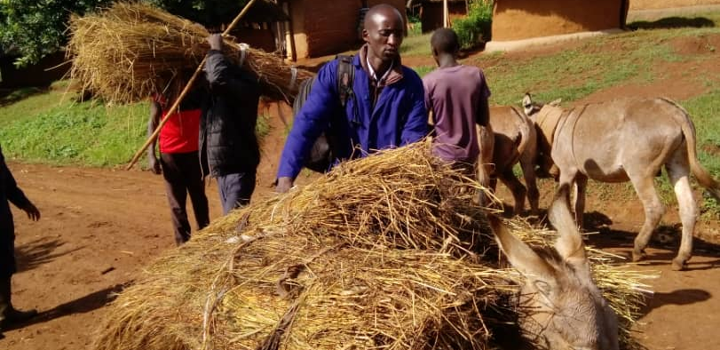
The fifth day was a market day in Kapchorwa a nearby trading center and one group member suggested we woke up early morning and see for ourselves how the donkeys were treated during transportation of goods to the market. It was observed that donkeys were undergoing a lot of suffering due to poor or no saddles, overloading and inappropriate loading where at one time when sticks would pierce the eyes.

A follow up program was suggested by the team so the two contact vets keep visiting these areas during especially the project period to advise the donkey owners how best they ought to manage the animals.

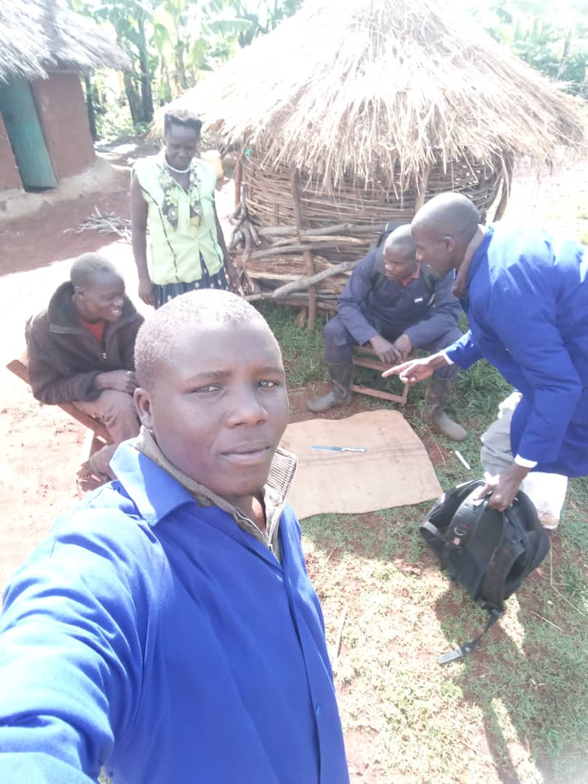
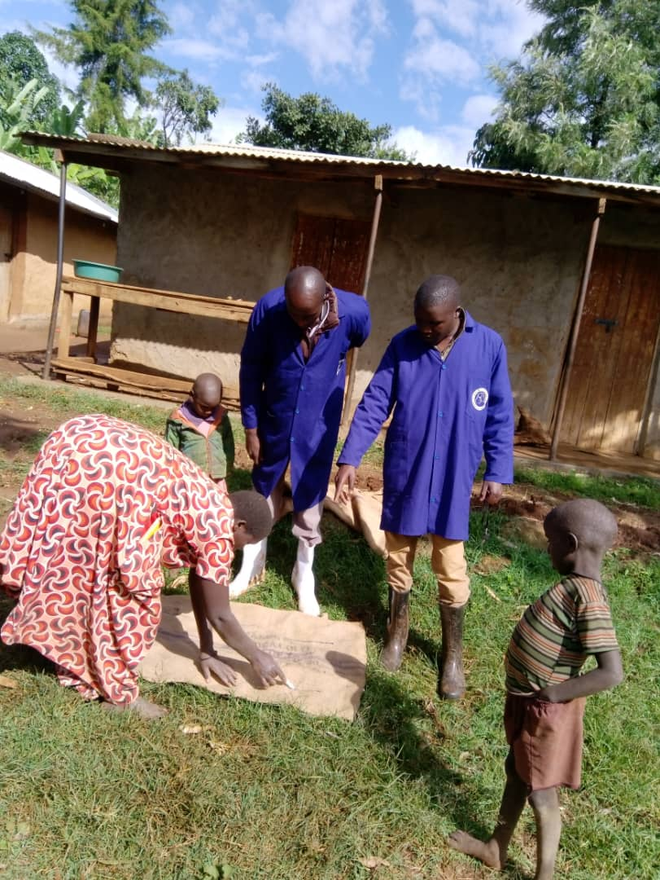

Milestone:
Our team was able to establish 20 trainers from 5 villages in Kono Parish.
The 20 trainers formed 4 groups each consisting of 5 ready to train members .
The groups were successfully trained to make saddles.
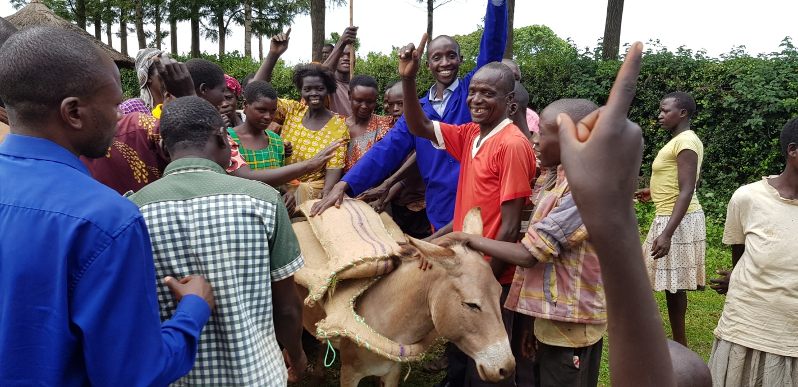
Both the trainers and the community highly welcomed the program.

Over 100 pairs of saddles were made by the trainers.
Over 50 families are using the saddle made from this project and their animals are feeling a bit confortable when used for transportation.
We expect gradual attitude change from negativity to positive attitudes towards animals particularly donkeys.
6. Achievements
Bam animal clinics has finally realized its dream to have their donkey welfare issues answered through the grant support from Animal Kind International.
Kono parish is now boasting with over 100 donkeys already using well cushioned and balanced Saddles.
The level of response towards the new innovation was high from day one resulting into quick adoption of making saddles.
Bam animal clinics successfully launched an animal welfare program in Sebei region and hope to strengthen our grip in the region.
Animal owners in this region can now test a more holistic approach to the welfare of their animals through Bam animal clinics supported by Animal kind international.
7. Issues -
Independence celebrations from 9th Oct disrupted our work as staff members were out of offices close to three days.
Need to consider Salaries to staff, Office,Transport, Accommodation and Food to participants and staff during training , Miscellaneous expenses as described in the Bam application form.
8. Lessons learned -
There gross suffering of working donkeys as they trekked long distances to ferry goods to markets.
The poor and very expensive transport means in the region that by no means force locals to resort to using animals for transport.
We realized animals go for long without getting any mediation and the use of even limping donkeys to carry goods to the market.
Foot note:
Bam animal clinics highly thanks our partners the Animal Kind International for their consideration to support our project. We reiterate our commitment to continue working together to ensure full transformation of the donkey welfare in the region.
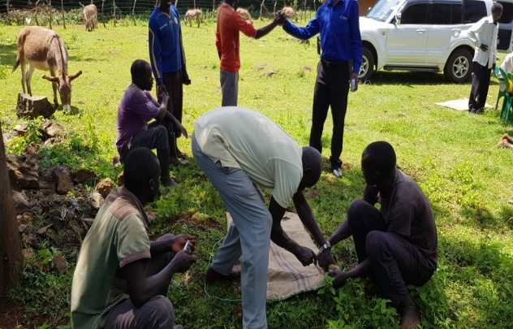
Long live AKI.
Prepared by: Mr Balondemu David
